Microstepping with PBM3960 and TEA3718

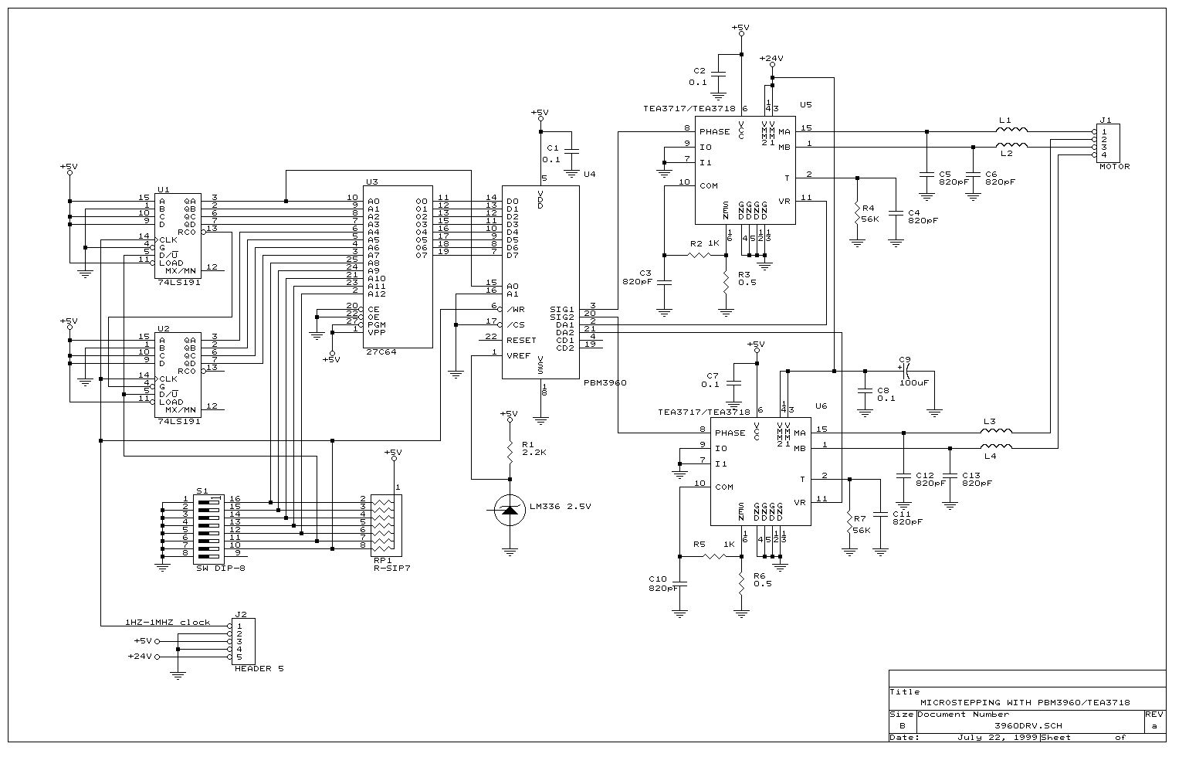
Introduction
This Circuit offers a short cut to get familiar with microstepping. It is a complete system to driver the bipolar stepper motor in microstepping mode as well as the half step and full step modes. This board is built around the Ericsson PBM3960 microstepping controller and TEA3718 motor driver.

Functional description
The circuit can be divided into three functional blocks, Microprocessor simulation logic, microstepping controller and stepper motor driver.
A. Microstepping simulation.
This block send the control signals normally sent by a microprocessor to the microstepping controller, the inputs to the block are the 5 Dip-switches and the clock pulse from pin1 of J2. During normal operation the current level in one of the motor windings is updates at every step pulse (single pulse programming). These mean two step pulses are required to update both winding currents and make the motor turn. Operating the dip-switched S1-6 can change the direction of the motor rotation
An eight bit counter, built up of two four bit counters U1 and U2 (74LS191), generates a 256 step sequence at their outputs. This is sent as an eight bit wide address (A0-A7) to the EPROM U3 (27C64). The counter increments or decrements (depends on S4 setting) the address at every positive transition on the step pulse. When the EPROM input address A0 is low the EPROM outputs data associated to driver channel 1. When A0 is high data associated to driver channel 2 is output from the EPROM. This means that 128 consecutive 2 byte entities in the EPROM make up one microstep cycle, which is equivalent to 4 full steps. The Dip-switches S1-S3 are directly connected to EPROM address A8, A9, and A10. This makes it possible to select 8 different microstep sequences (blocks) without changing the EPROM contents.
B. Microstepping controller
This block converts the digital signals from the EPROM into two analog signals VR1 and VR2, which control the current levels in the two motor windings. It also generates the digital signals SIGN1 and SIGN2 to control the direction of the current in the windings.
Refer to PBM3960 data sheet for more information.
C. Stepper motor driver.
The driver controls the winding currents in accordance to the analog and digital input signals. The current control is switch mode constant current (chopper) to minimize power losses. The chopping is controlled by a fix frequency PWM method. The driver is implemented with the TEA3718 or PBL3718 stepping motor driver. Refer to TEA3718 data sheet for more information.

Modified the current wave forms
By changing the data stored in the EPROM it is possible to generate different current waveform. For instance it is possible to modify the sine/cosine curves to get minimum microstepping position ripple. It is also possible to generate microstepping sequences with other step lengths. The following lengths are possible 1/32(default microstep), 1/16, 1/8, 1/4, 1/2, and full step. For all sequences all the 128 two byte entities of the EPROM have to be programmed due to the 8 bit counter driving the EPROM. It is good idea to stretch all sequences to 128 step sequences to get the same motor speed independently of the step length. This is done by repeating every 2-byte entity 2, 4, 8, 16 or 32 times when not 1/32 stepping mode is used.
The 2 byte entities contain the two 7 bit DA register data and 1 bit sign data for the two DAC in the PBM3960. DAC1 data is stored on even addresses and DAC2 data on odd addresses. Bit0 -6 set the amplitude of the current and bit7 sets the sign.
One data block stores one sequence and occupies 256 consecutive addresses in the EPROM. It is possible to access 8 different blocks with the Dip-switches S1-1 to S1-3 setting. More blocks can be used if needed by utilize the addresses A11 and A12.

Quick Start
To run the board you need the following things, One pulse generator, 1HZ ~1MHZ, with TTL output levels. One +5V power supply, capable of delivering 200mA. One power supply for the motor voltage, preferable variable output from 10 to 40VDC,maximum output current 1Ampere or more. A bipolar stepper motor with rated current less than 1Ampere and rated voltage less than 20V. The nominal drive current is 415mA, with a simple modification on the value of the current sensing resistors you can adapt the board for any current up to an ampere.
Make sure the power supplies off. Connect the motor, power supplies and pulse generator to the board. Check that all connections are OK. Turn the power on in the following order. First +5V supply, then motor supply and last pulse generator. Change the pulse generator frequency to examine the motor behavior at different stepping frequencies. The direction of rotation can be changed with the DIP-switch S1-6.
Microstepping greatly improves stepping at low frequencies and in most case also at frequencies around the system resonance frequency.
See Table 1 EPROM address setting for selecting the difference stepping modes. First try to run the motor at full step with low frequency, 250HZ for instance (this corresponds to approximately 4HZ per step). Notice the rotor movement, and then change to the half step mode, finally switch to the microstepping. That clearly shows the benefits of using microstepping when running a stepper at low frequencies. No matter how low the frequencies you set, there will be less noise problems with microstepping. This is due to the low amount of energy transferred to the motor per microstep.
To achieve the smoothest possible microstep movements at the lowest frequencies it is almost always necessary to develop a customized Sine/Cosine current profile. The profile compensates for the motor sine/cosine deviation. If microstepping position ripple is of less importance and microstepping is used only for reduction of noise then the standard sine/cosine profile usually does the job. The EPROM on the board contains in addition to the standard profile two customized sine/cosine profiles.
Run the motor at a very low frequency 50HZ, for instance. Set the standard sine/cosine profile and observe the rotor movement. Use a pointer to observe the movement more clearly. If the velocity ripple is too large for the actual application, then use a more microstepping adapted motor or develop a customized sine/cosine current profile. Switch to the modified sine/cosine profiles to see if this improves the movement. Refer to the microstepping application note for more information.

Table 1 EPROM address setting.

Block S1-5 S1-4 S1-3 S1-2 S1-1 Description

0 ON ON ON ON ON Standard 1/32 step sine/cosine
1 ON ON ON ON OFF Modified sine/cosine 1
2 ON ON ON OFF ON Modified sine/cosine 2
3 ON ON ON OFF OFF Full step mode
4 ON ON OFF ON ON Half step mode
5 ON ON OFF ON OFF These blocks can be used for customized
- - - - - application specific microstepping sequences
31 OFF OFF OFF OFF OFF

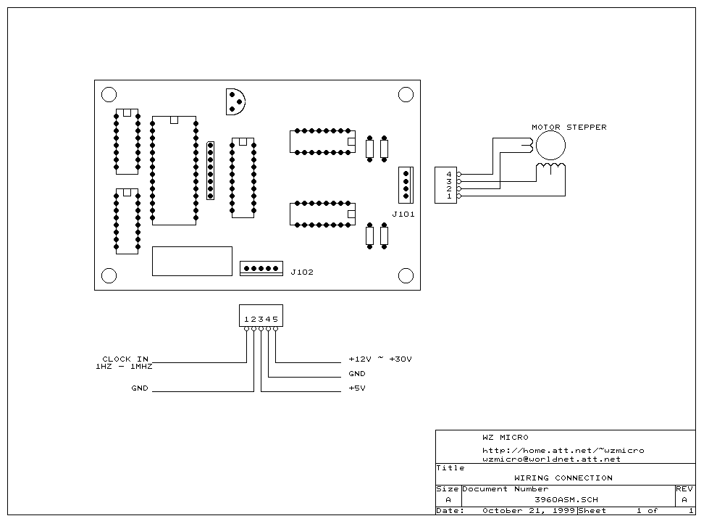

The following is a sample of 1/32 step sequence:

$000000,7F 06 7E 0C 7E 13 7D 19 7B 1F 7A 25 78 2B 75 31
$000010,73 36 70 3C 6D 41 6A 47 66 4C 62 51 5E 55 5A 5A
$000020,55 5E 51 62 4C 66 47 6A 41 6D 3C 70 36 73 31 75
$000030,2B 78 25 7A 1F 7B 19 7D 13 7E 0C 7E 06 7F 00 7F
$000040,86 7F 8C 7E 93 7E 99 7D 9F 7B A5 7A AB 78 B1 75
$000050,B6 73 BC 70 C1 6D C7 6A CC 66 D1 62 D5 5E DA 5A
$000060,DE 55 E2 51 E6 4C EA 47 ED 41 F0 3C F3 36 F5 31
$000070,F8 2B FA 25 FB 1F FD 19 FE 13 FE 0C FF 06 FF 00
$000080,FF 86 FE 8C FE 93 FD 99 FB 9F FA A5 F8 AB F5 B1
$000090,F3 B6 F0 BC ED C1 EA C7 E6 CC E2 D1 DE D5 DA DA
$0000A0,D5 DE D1 E2 CC E6 C7 EA C1 ED BC F0 B6 F3 B1 F5
$0000B0,AB F8 A5 FA 9F FB 99 FD 93 FE 8C FE 86 FF 80 FF
$0000C0,06 FF 0C FE 13 FE 19 FD 1F FB 25 FA 2B F8 31 F5
$0000D0,36 F3 3C F0 41 ED 47 EA 4C E6 51 E2 55 DE 5A DA
$0000E0,5E D5 62 D1 66 CC 6A C7 6D C1 70 BC 73 B6 75 B1
$0000F0,78 AB 7A A5 7B 9F 7D 99 7E 93 7E 8C 7F 86 7F 80
$000100
.
.
.
.
$0007FF

The preprogrammed 27C64 with standard 1/32 step sine/cosine, half step, full step, modified sine/cosine sequences and all other parts can be purchased from us. If you need help or have any comments on this project, please send it to wzmicro@worldnet.att.net

