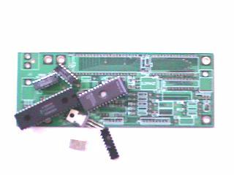
Assembling the board should be very simple and straightforward. Make sure you use the IC sockets for U1 and U5. We hope that we don't need to show you how to identify the resistor or capacitor value, IC and diode orientation etc. but if you do need just let us know.
Use heat-sink on the Q1 (7805), Q2 does not need it. The ZD1 & ZD2 are options, you may just use the jumper wire or 0 Ohm resistor instead. The locking tab of the 6pin and 9pin headers for J2, J3 and J4 are facing the outside edge of the board. If you look at the solder side of the PC board, the square pad is pin1. Make sure you put the shunt on J5. The finishing board should look similar to this picture.
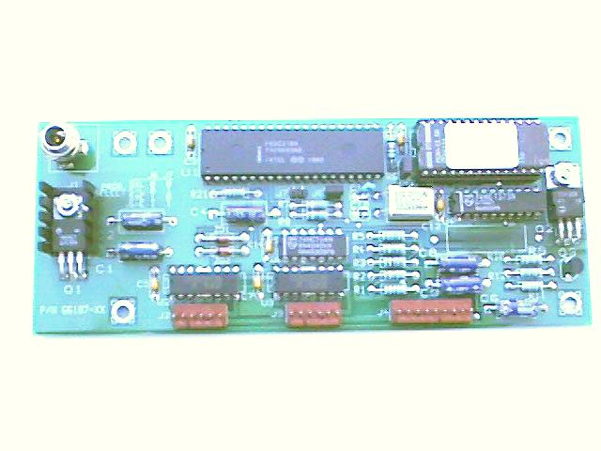
The motors are connected to J2 and J3. Incorrect motor winding connections may damage the driver chip; see the picture below for proper motor connections.
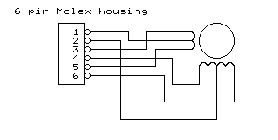
Figure 2 Stepper Motor connections
The MD4 is a basic design of 8031 microcontroller; the design is very similar to the MD-2 board except that this board has the on-board +5V regulator so it does not require a dual voltage power supply to run. . It uses two Allegro UDN2540B ICs as motor drivers. The U1 is 8031AH microcontroller which can be replaced with any 80C32, 87C51, 87C52 or flash base microcontroller 89C51, 89C52 families.
The port P1.0~P1.7 generate the step sequences to drive the stepper motors with U2 and U3 (UDN2540B). The port P3.4 and P3.5 enable/disable the power supply to the motors. You may wonder why does the design use Q2 & Q3 to turn on/off the power to the J2 motor instead of the using the enable pin on U2? Well, in some applications, which require the motor to lift a heavy load, if the simple belt drive or gears drive system is used, then when the motor is stopped, the holding torque of the motor alone may not able to hold the load in place. Of course using the worm gear or lead screw can easy solve the problem but they are not cost effective. If we apply some low voltage to the motor after it stop, that enough to lock the motor in place without overheat the motor, this way will increases the holding torque and serves the same purpose without adding cost to the whole system.
When Q2 is cut off, there’s still some voltages apply to the motor winding thru R9. You may need to change the R9 value depending on the motor winding resistance. The R9 is omitted if there is no need to increase the motor holding torque.
In our EPROM sample code, we configured the J4 as input ports for controlling the two motors. Their functions are as follows:
J4-Pin1-------- Motor0 enable
J4-Pin4-------- Motor0 direction
J4-Pin6-------- Motor1 enable
J4-Pin8-------- Motor1 direction
Shorting the pin1 to ground (pin2) will turn on the Motor0 in one direction, with the Pin4 shorts to ground first then Pin1, the Motor0 will rotate in opposite direction. Same functions are on Pin6 and Pin8 for Motor1. Jumper J6 and J7 are not used in our sample code, but you may change the program so that with the different jumper setting on J6 & J7, the motor will run at different speed.
You can download the Intel hex code and the source file here. We offer the MD4 as a kit so you can build it yourself and customize it as needed.
These parts can be purchased from us:
Parts List
High quality double sided MD4 bareboard $6.00
8031AH 12MHZ Microcontroller(removed from board) $0.30
27C64 Programmed EPROM $0.50
Two UDN2540B $2.00
12MHZ or 11.0592MHZ Crystal $1.00
74LS373 $0.10
74LS04 $0.10
TIP30 $0.30
7805 linear voltage regulator $0.25
Order the KIT which includes all the components for just $9.50 plus shipping/handling.

